Here are some Screenshots of Backend Of Project

CODE Review 1 : Spam or Ham Detection, Sentiment Analysis, Stress Detection, Hate & Offensive speech, Sarcasm Detection

**Spam Detection Prediction:**

Model is trained using CSV file (Comma Separated Values) Spamdetection.csv

Using “Fit Transform” function the model is able to remove pronouns, articles and other non useful information from the CSV file.

After that Trained model works on the given input and predicts the output of sentence.

***\*Same Process is applied all over other MACHINE LEARNING MODEL\****

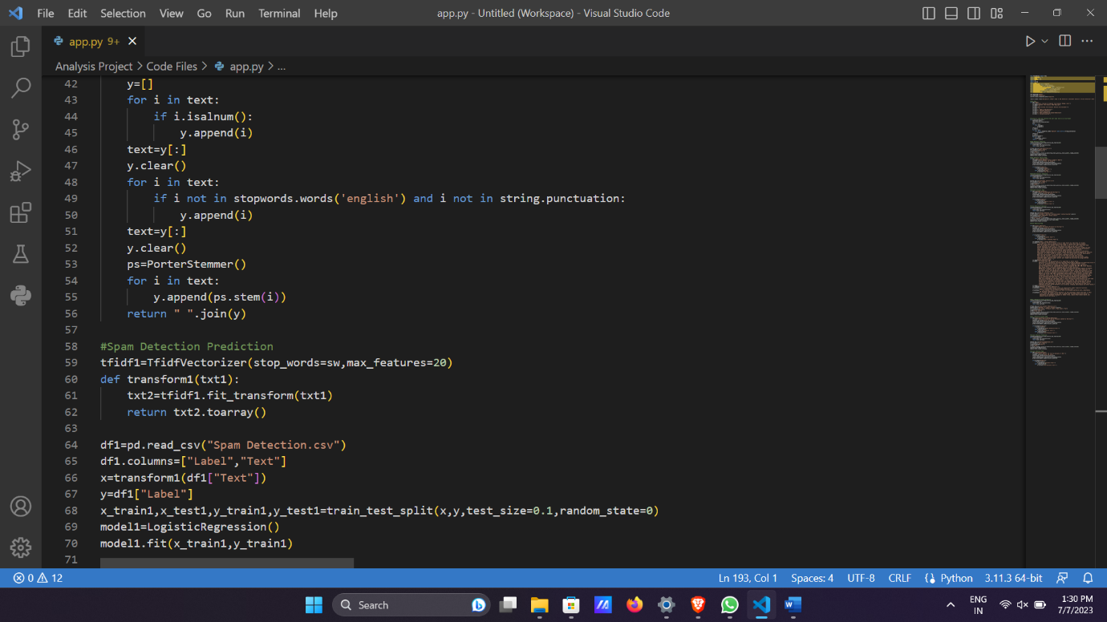

**Spam Detection Analysis**:

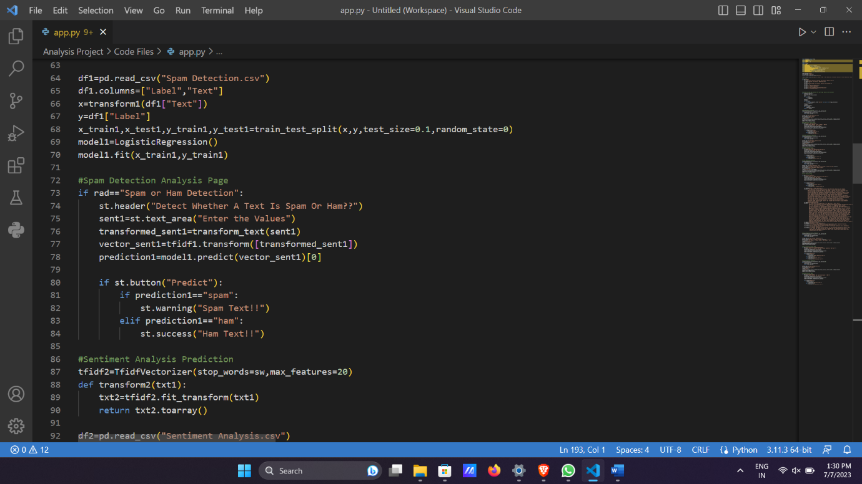

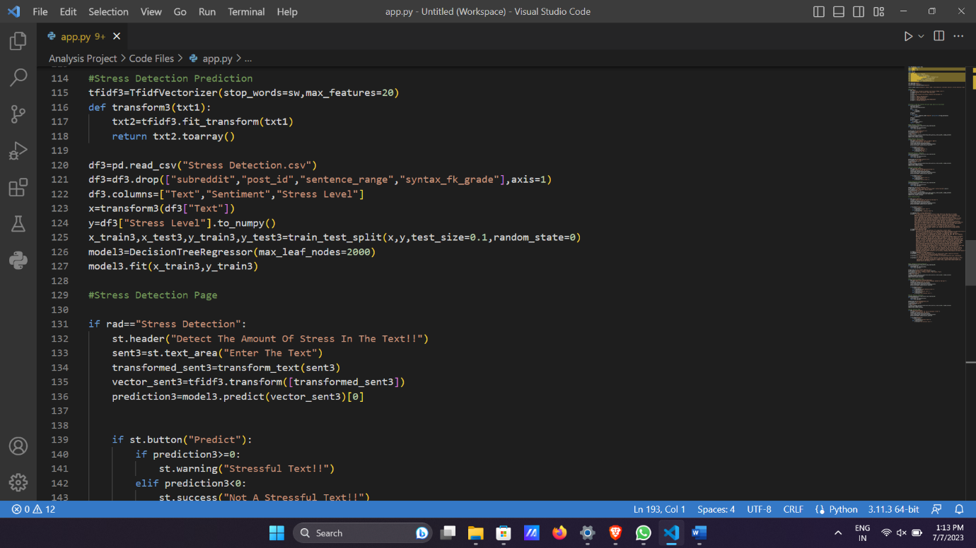**Stress Detection Prediction:**

**Hate And Offensive:**

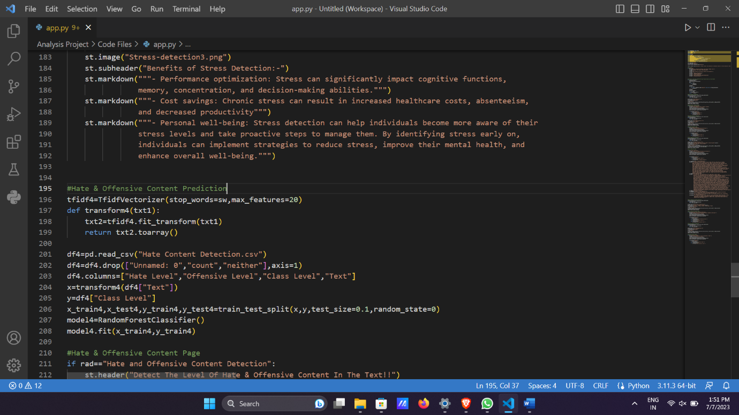

**Sarcasm Detection:**

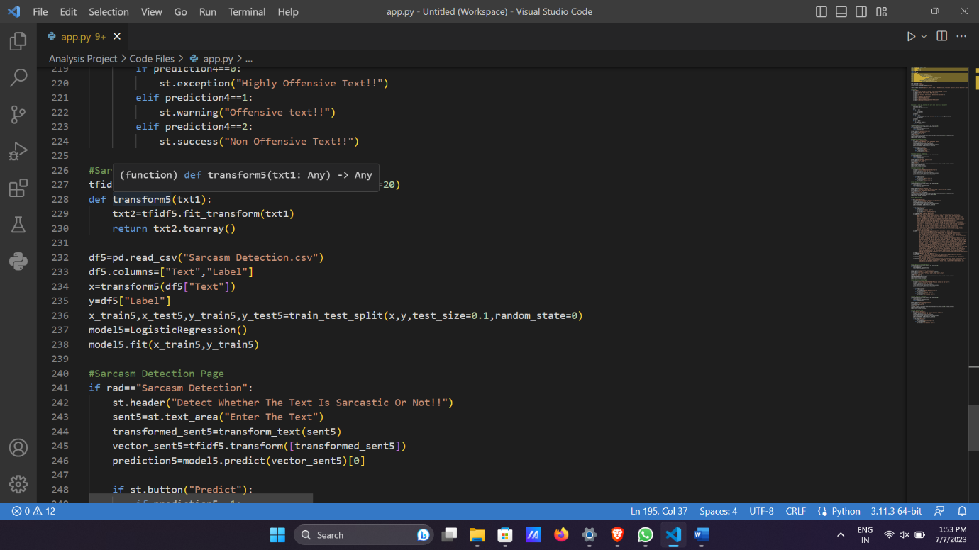

**Sentiment Analysis:**

